Crosby House Bank

Contents

Analysis 3

Description 3

Stakeholders 4

Why my project is amenable by a computational Approach. 5

Project Research 6

Interview with Primary Stakeholder 6

Similar Solution 1: Barclays Online Banking 7

Similar Solution 2: HSBC Online Banking 14

Computational Thinking 15

Success Criteria 16

# Analysis

## Description

My project Idea is to create a database for my boarding house that eases the management of the house bank. The Crosby House Bank allows pupils to deposit cash for safe keeping in the house safe and then withdraw the cash in large sums or small amounts . Currently this process is almost completely physical with pupils asking the Housemaster or Deputy Housemaster to withdraw money from the safe. Therefore the aim of my project is to make a web based database that allows pupils to ask for money digitally as well as allowing pupils to check how much money they have in house bank. It will also allow the house master and deputy house master to easily track who has asked to withdraw money and who has deposited money.

## Stakeholders

For my project I intend to have two levels of stake holders:

* **Primary Stake Holder**: Mr Arnold(Deputy Housemaster of Crosby Houser) :
  + Mr Arnold is currently the person in charge of managing the house bank. This means he receives cash from the student and deposits it in house bank as well as giving students money out of house bank when they request cash. This also means he is in charge of tracking how much money each student has in house bank and whether a student has drawn out too much money to the point where they are in debt. The project will allow Mr Arnold to view student balances because this will make it easier for him to view which students are currently in debt and by how much they are in debt. Furthermore, the project will allow him to manage student balances completely electronically by inputting the amount a student has deposited or withdrawn which will make it much easier to control student balances. In addition to this Mr Arnold currently has to tell students in person when they are in debt to house bank and how much money they owe, in person. Therefore this project will allow him to notify students remotely making the process much quicker.
* **Secondary Stakeholder:** Students of Crosby House.
  + The students of Crosby house currently make use of the house bank as it allows them to store cash in safe so that it is secure and then withdraw amounts at a later date. Students also use house bank for convenience. For example, when people come around house collecting money for charity or staff gifts, students can choose to use money from house bank to cover the costs of their donation instead of using Cash. However when students want to take money out of house bank they have to knock on Mr Arnold’s door and ask to take money out of house bank. Therefore my project will allow the students to request money out of house bank remotely via the house bank website. In addition to this students currently do not have any way of checking how much money they have in their house bank. Therefore students will be able to use the house bank website to check their balances in house bank.

## Why my project is amenable by a computational Approach.

* One of the features of my project is that I want to allow individual students to view the amount of money they currently have in house bank without being able to view other people’s accounts. This is amenable by a computational approach as I will need a login system online so that the students can view their own house bank balance and not another students. Furthermore, I will need an admin login so that only Mr Arnold can manage the house bank database and no other person that is not an admin.
* Another feature that my project will have is remote access to their house bank balances. This will be done via a website that Crosby students will be able to acess via their web browser. This is therefore can only be done via a computational approach as a physical approach does not allow students to acess their balances from anywhere they want whereas a computational approach will allow students to access the database online.
* Furthermore I intend for my project to provide automatic updates when students are in debt to both the student and the house master. This is amenable by a computational approach as I intend to send the automatic updates via email or teams notifications. Therefore a non-computational approach would not allow

## Project Research

#### Interview with Primary Stakeholder

### Similar Solution 1: Barclays Online Banking

For this I will be analysing the Barclays banking mobile application. This will allow me to look at how some banking apps are laid out on a mobile phone. All screenshots have been taken from a Barclays Banking video so there is no sensitive information.

**Main Page for Barclays Banking**

This is a good example of a home page. I like how it displays the balance on the account on the main page. I also like the bar a the bottom allowing to go to different parts of the interface. However I dislike the amount of different features there are on the main page. For my project the website will not offer as many features. For example rewards and products are completely unnecessary features that my project will not offer. In addition I like how there is a help button to explain how to use the website.

**Page Displaying Balance and Transactions.**

This page displays the account balance. I like the layout of the interface with account balance at the top of the page. I also like how it displays the transaction history of the account with amounts next to the transaction. I also like how it shows what each transaction was for example super market. I think I will use this feature so that the students can keep track of what they used their house bank money for. I do not intend to use a search transactions as it will be to complicated to implement. I also do not intend to allow students to manage their own accounts however the manage an transaction bar will be useful for the administrator to have when viewing student accounts.

**Credit Card Page.**

This is a completely unnecessary feature as my project will not use credit or debit cards.

**Login Page for Barclays account**

This website uses a 5 digit passcode to login to the online banking system. I do not think I will implement this into my project as this banking system remembers the user so all it needs to do is get confirmation that it is the user logging into the account. However for my project the website will not be able to identify that it is the same user logging on therefore it will need a username and password to login.

**Payment System for Barclays Online Banking**

My system will not be using cheques so this is an unnecessary feature.

This payment process is much more complicated than the payment process that the house bank will have. This is because for this payment you have to select the account that you want to send from and the account you want to send to. However with my project you will only be dealing with one accounts as you will either be depositing money into house bank or withdrawing money from house bank.

I like this confirmation page as it allows you to make another transfer. Furthermore I like the big tick in the middle of the page and will be implementing this into my project. I will probably use this page as a guide for the completion of payment page.

### Similar Solution 2: HSBC Online Banking

HSBC also has an online banking app and website. This provides me a good example of how I might layout my website on a desktop format. It will also provide insight into the functionality of an online banking site.

**Main Banking Page**

In this image I really like the layout of the menu bar at the top of the screen. Similar to Barclays banking my website will not have as many features so there will not be as many things in the nav bar. I prefer this layout of the navbar at the top of the screen much better than the navbar at the bottom of the screen. However I do not like the collapsable menus as the can cause the website to get quite messy and the colour scheme is very bland. Furthermore I do not like how the menu bar is stays in the upper middle part of the screen instead of the top

**Individual Accounts**

I like the simplicity of the layout. However the dropdown menus again make the website to complicated and means there needs to be a sperate manage button for no reason. I will not implement this.

**Transactions**

This is a clean layout for tracking transactions and the simplicity something I hope to replicate. Furthermore having pending transactions being able to be viewed and separated from the history. This will be useful in my database as it will allow students to view whether the money they have requested from house bank in cash has gone through. However I don’t think I will have amount out or amount in seperated and will probably just have + or – amounts displayed in transaction history

This specific online banking system uses usernames to allow users to log in to the system. This is better than the Barclays method as it does not relay on the device remembering the user. I will implement something like this in my database system.

In HSBC and most online banks they require either a digital secure key generated by your phone or by a physical secure key. This is too complicated for my system so I don’t think I will be using this and will stick with a reusable password instead of a one time key

### Similar Solution 3: PayPal.com

### Similar Solution 4: Local ATM

Since my system is basically an ATM that is online, I thought looking at a real ATM and analysing the features would be useful to provide some ideas for features of my website.

**Main Page**

This is a very simple homepage. There are not many features which allows the layout of the homepage to be very simple. However since the ATM is controlled by buttons on the side instead of mouse and keyboard or touch screen it makes the user interface very different inputs on screen have to be in line with the side buttons. Also the colours are very un-appealing.

**Balance Page**

Very Simple. Not many features. Does not display transactions as it is not viewing personal bank account. My website will not have available or current balances. My system will also not have the ability to print the balance either.

**Cash Withdrawal Page**

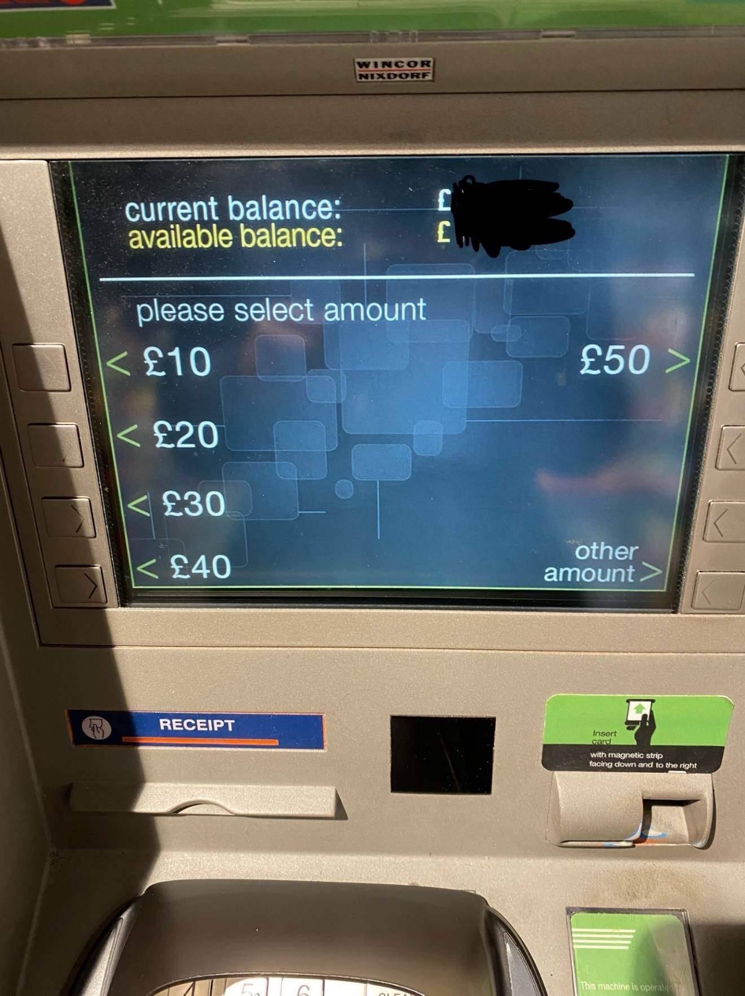

Only allows users to withdraw set amounts. Even when withdrawing other amounts users can only withdraw in multiples of ten which is quite impractical. In my database i hope to allow students to input any amount of money they wish to withdraw as long as it is a whole number.

**Other Services**

## Computational Thinking

## Success Criteria